SOC Operations: Alert Analysis, Incident Handling, and Forensic Practices
Kanchi Kakkad
Cyart
24/12/25
Internship Week 3 Documentation

- Introduction

This report documents the practical Security Operations Center (SOC) activities performed during Week 2 of the internship. The objective of this week was to gain hands-on experience in monitoring, analyzing, and responding to security events using a SIEM-based environment. The tasks focused on advanced log analysis, threat intelligence integration, alert triage, incident escalation, evidence preservation, and end-to-end incident handling. The lab environment consisted of a SOC Manager system (VM1) and an Endpoint/Agent system (VM2), simulating real-world SOC operations.

- Task 1: Advanced Log Analysis

The first task focused on analyzing system logs to identify suspicious activity by correlating multiple events rather than relying on single alerts. On the endpoint system (VM2), repeated SSH authentication failures were generated. These events were recorded in the Linux authentication log file (/var/log/auth.log). The Wazuh agent running on the endpoint continuously monitored this file and forwarded the log entries to the SOC Manager (VM1).

On the SOC Manager, the SIEM dashboard was used to filter and analyze SSH-related events. By applying filters such as agent name, time range, and keyword search, multiple failed login attempts occurring within a short time window were observed. This pattern indicated abnormal behavior when compared to normal user activity and suggested a possible brute-force attempt. This task demonstrated how centralized logging and event correlation help SOC analysts detect attack patterns that are not evident from isolated events.

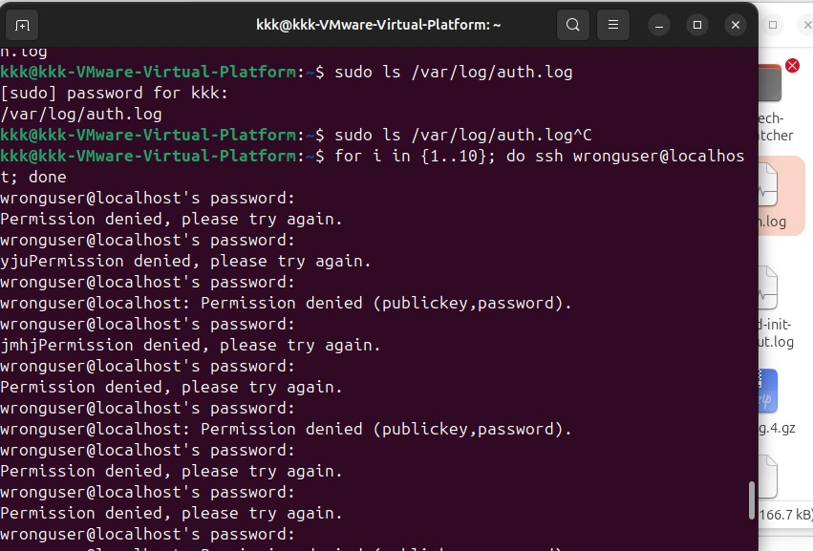

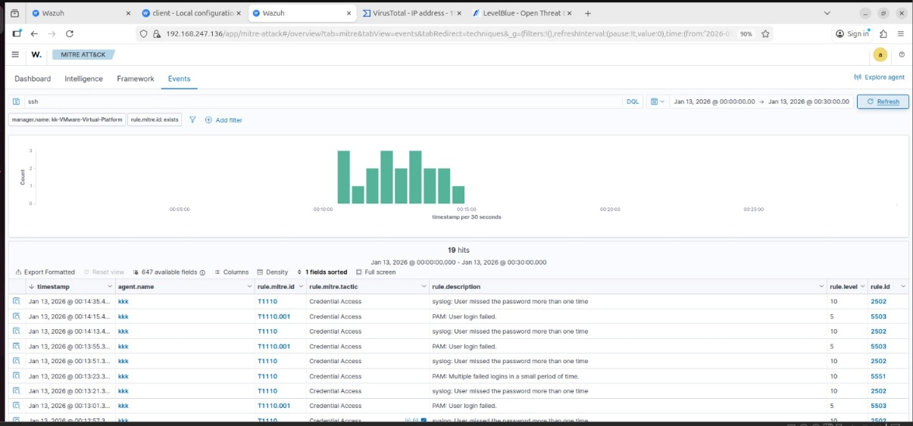

- Task 2: Threat Intelligence Integration

In this task, external threat intelligence was used to enrich and validate the alerts identified during log analysis. The source IP address associated with the SSH authentication failures was extracted from the SIEM alert. This indicator was then analyzed using external threat intelligence platforms such as VirusTotal and AlienVault OTX.

VirusTotal was used to assess the reputation of the IP address by checking it against multiple security engines and intelligence databases. AlienVault OTX was used to determine whether the indicator appeared in any known threat pulses. The results showed that the IP address was an internal/private address with no known malicious reputation. Although no malicious activity was identified, the process demonstrated how SOC analysts validate indicators and avoid unnecessary escalation.

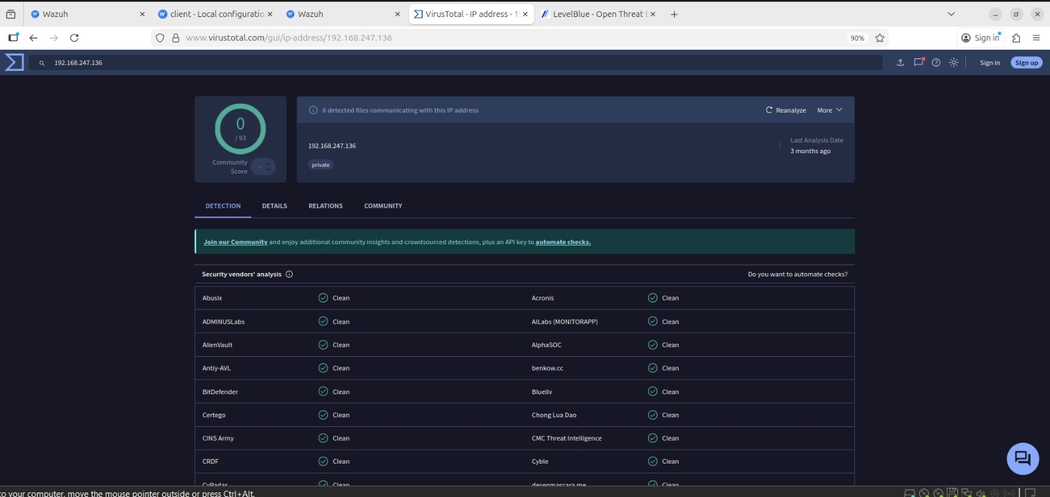

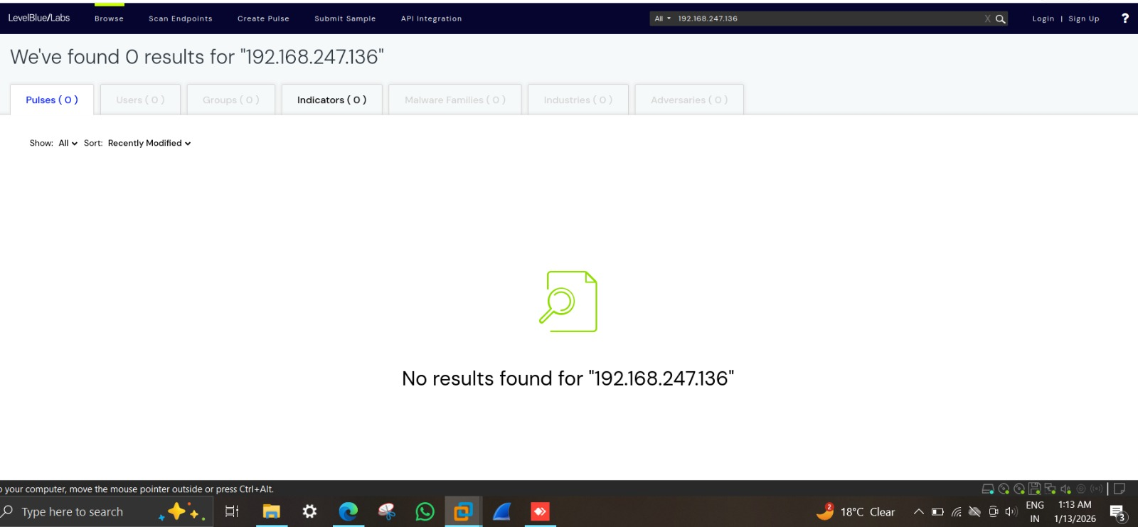

- Task 3: Alert Triage and Classification

Alert triage was performed to determine whether the detected alert represented a real security issue and to assign an appropriate severity level. The alert details in the SIEM were reviewed, including rule ID, rule description, severity level, timestamp, source IP, and associated MITRE ATT&CK technique.

The frequency and pattern of the SSH authentication failures were analyzed, confirming that the activity was abnormal and repetitive. Based on this analysis, the alert was classified as a true positive with medium severity. The triage decision was documented in a structured table, capturing key details such as alert ID, description, source, target system, severity, and analyst verdict. This task highlighted the importance of analyst judgment in prioritizing alerts and managing SOC workload effectively.

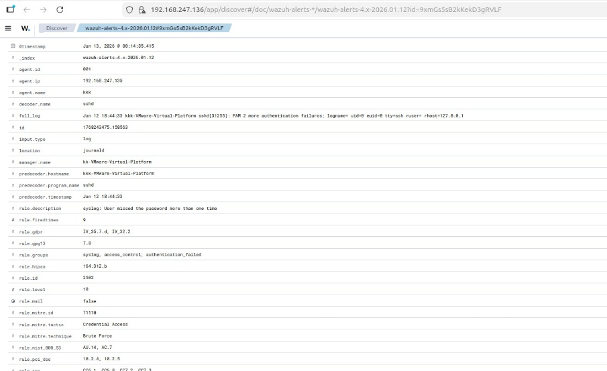

Alert Triage Documentation Table

Field | Details
Alert ID | ALRT-SSH-001
Alert Description | Multiple SSH authentication failures detected
Detection Tool | Wazuh SIEM
Affected Asset | Ubuntu Endpoint (VM2)
Agent IP | 172.20.10.5
Source IP Address | 127.0.0.1
Timestamp | <DD-MM-YYYY HH:MM IST>
Rule ID | 2502
Rule Level (Severity) | Medium
MITRE ATT&CK Technique | T1110 – Brute Force
Alert Frequency | Multiple events within a short time window
Threat Intelligence Check | VirusTotal, AlienVault OTX
Threat Intelligence Result | No known malicious reputation
Analyst Assessment | Repeated authentication failures indicate suspicious activity
Triage Verdict | True Positive
Incident Severity | Medium
Recommended Action | Monitor activity and escalate for further investigation
Alert Status | Open / Escalated

- Task 4: Incident Escalation Practice

Following triage, the incident was escalated from Tier-1 to Tier-2 SOC for further investigation. The escalation decision was based on the repeated nature of the activity and the potential risk of credential misuse. A Situation Report (SITREP) was prepared to communicate the incident clearly to the higher-tier team.

A copy of the log file was created and stored in a secure directory with read-only permissions to prevent modification. All evidence-related details, including file path,
hash value, date and time of collection, and analyst name, were documented. A chain of custody record was also maintained to track every action performed on the
evidence. This ensured traceability, integrity, and compliance with forensic standards.

Incident Escalation Summary (SITREP)
Incident Title: SSH Brute-Force Authentication Attempts on Ubuntu Endpoint
Incident ID: INC-SSH-001
Detection Time: 15-01-2026, 19:45 IST
Detected By: Wazuh SIEM
Affected Asset: Ubuntu Linux Endpoint (VM2)
Source IP Address: 127.0.0.1
MITRE ATT&CK Technique: T1110 – Brute Force

Incident Summary:
Multiple SSH authentication failures were detected on the Ubuntu endpoint within a short time window. The activity indicates a potential brute-force attempt targeting user credentials. Alert triage confirmed the incident as a true positive with medium severity. Threat intelligence validation showed no known malicious reputation for the source IP, indicating internal testing or misconfiguration.

Actions Taken by Tier-1 SOC:

- Analyzed and correlated SSH authentication logs
- Validated indicators using VirusTotal and AlienVault OTX
- Preserved authentication log evidence
- Documented triage findings

Reason for Escalation:
The repeated nature of the activity requires further investigation to determine potential credential misuse or system misconfiguration.
Current Status:
Escalated to Tier-2 SOC for further analysis

- Task 5: Evidence Preservation and Chain of Custody

In this task, digital forensic best practices were applied to preserve evidence related to the incident. The authentication log file (/var/log/auth.log) was identified as relevant evidence. The file’s existence was verified, and a cryptographic hash was generated using the SHA-256 algorithm to ensure integrity.

A copy of the log file was created and stored in a secure directory with read-only permissions to prevent modification. All evidence-related details, including file path, hash value, date and time of collection, and analyst name, were documented. A chain of custody record was also maintained to track every action performed on the evidence. This ensured traceability, integrity, and compliance with forensic standards.

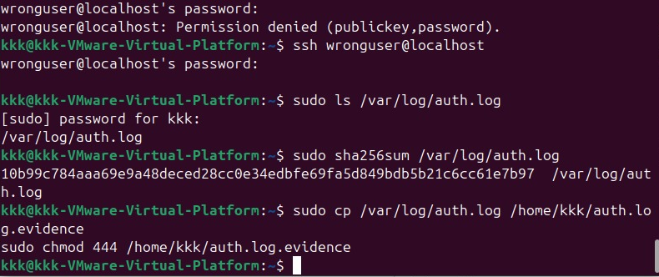

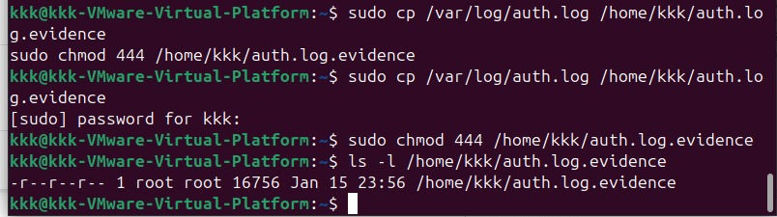

Chain of custody table

Date | Time (IST) | Action Performed | Evidence Item | Responsible Person
15-01-2026 | 20:10 | Identified authentication log as evidence | /var/log/auth.log | SOC Analyst
15-01-2026 | 20:12 | Verified evidence file availability | /var/log/auth.log | SOC Analyst
15-01-2026 | 20:15 | Generated SHA-256 hash of evidence | /var/log/auth.log | SOC Analyst
15-01-2026 | 20:18 | Created read-only forensic copy | auth.log.evidence | SOC Analyst
15-01-2026 | 20:22 | Documented evidence and custody details | auth.log.evidence | SOC Analyst

- Task 6: Capstone – Full SOC Workflow Simulation

The capstone task integrated all previous activities into a complete SOC incident handling workflow. Suspicious activity was generated on the endpoint, detected by the SIEM, analyzed through log correlation, enriched with threat intelligence, triaged, escalated, and documented. Evidence was preserved following forensic best practices, and a structured incident report was prepared.

In addition to technical documentation, a concise management briefing was created to summarize the incident and response actions in non-technical language. This demonstrated the ability to communicate effectively with stakeholders. The capstone task reflected real-world SOC operations and validated the ability to handle incidents end-to-end.

8. Conclusion

The activities performed during this week provided comprehensive exposure to real-world SOC operations. Through log analysis, threat intelligence validation, alert triage, escalation workflows, evidence preservation, and reporting, the tasks simulated the complete incident response lifecycle. The practical exercises strengthened analytical skills, reinforced the importance of structured processes, and emphasized accurate documentation and communication. Overall, this week’s assignment enhanced readiness for operational roles within a professional Security Operations Center.

